hen we think of cloud, we imagine a place with large number of machines in big rooms. There must be a place where all the data is stored. Microsoft has datacenters all over the world from where Windows Azure services are managed. Datacenters are divided in regions. The exact location of these datacenters is not revealed by Microsoft for obvious security reasons.

Following are the 20 listed regions as can also be seen in the image.

* Central US
* East US
* East US 2
* US Gov Iowa
* US Gov Virginia
* North Central US
* South Central US
* West US
* North Europe
* West Europe
* East Asia
* Southeast Asia
* Japan East
* Japan West
* Brazil South
* Australia East
* Australia Southeast
* Central India
* South India

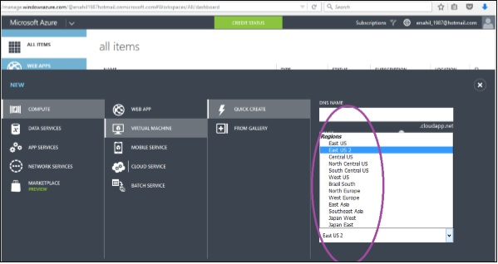

How to Choose the Right Data Center for Your Application

When creating Windows Azure application, whether it is mobile application, web application or database storage it asks to specify the region. Region here specifies a regional datacenter.

**Performance** − You should select the nearest datacenter to the users of your application. The performance can be affected by the relative location of the users who want to access the application. If a user is closer to the datacenter, the performance will be better.

**Cost** − The price of hosting the application may also increase or decrease depending upon the datacenter you choose. Price actually can vary according to the database hosting location or any other service being used by the application. You should choose the same location for all the services that are being used by your application. For example, database or any media service. If they are kept in separate datacenter there will be charges per transaction, but anything extra won’t be charged if they are kept at the same datacenter.

**Legal Aspect** − Laws vary from country to country and restrictions could be enforced in some regions on what information can be shared and what cannot.